UD1 - PRÁCTICA 4: ARITMÉTICA BINARIA

Para sumar:

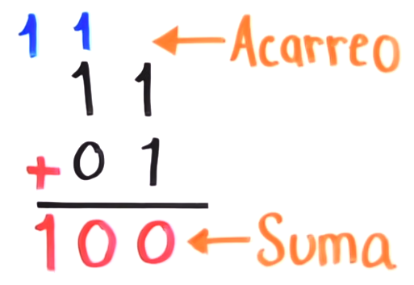

Para restar:

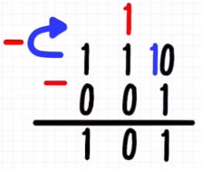

Realizar las siguientes operaciones:

1. 110100 + 101100
2. 111000 + 110000
3. 100111 + 111111
4. 101000 + 100011
5. 110101 + 110001
6. 1001110 – 100100
7. 1010101 – 110100
8. 1001111 – 100110
9. 1001101 – 101001
10. 1001101 – 100100
11. 10111 * 110
12. 1000 * 110
13. 1111 * 111
14. 11100 * 111
15. 11011 * 101

110100 + 101100

|  |  |  |  |  |  |  |
| --- | --- | --- | --- | --- | --- | --- |
| ACARREOS | 1 | 1 | 1 |  |  |  |
| BINARIO 1 | 1 | 1 | 0 | 1 | 0 | 0 |
| BINARIO 2 | 1 | 0 | 1 | 1 | 0 | 0 |
| RESULTADO | 1 1 | 0 | 0 | 0 | 0 | 0 |

Solución: 1100000

1001110 – 100100

|  |  |  |  |  |  |  |  |
| --- | --- | --- | --- | --- | --- | --- | --- |
| ACARREOS | 1 |  |  |  |  |  |  |
| BINARIO 1 | 1 | 0 | 0 | 1 | 1 | 1 | 0 |
| BINARIO 2 |  | 1 | 0 | 0 | 1 | 0 | 0 |
| RESULTADO | 0 | 1 | 0 | 1 | 0 | 1 | 0 |

Solución: 101010

10111 * 110

|  |  |  |  |  |  |  |  |
| --- | --- | --- | --- | --- | --- | --- | --- |
| BINARIO 1 |  |  | 1 | 0 | 1 | 1 | 1 |
| BINARIO 2 |  |  |  |  | 1 | 1 | 0 |
|  |  |  | 0 | 0 | 0 | 0 | 0 |
|  |  | 1 | 0 | 1 | 1 | 1 |  |
|  | 1 | 0 | 1 | 1 | 1 |  |  |
| RESULTADO | 10 | 0 | 0 | 1 | 0 | 1 | 0 |

Solución: 10001010